DPRC Diffusion Preprocessing Pipeline

Preprocessing script for DPRC diffusion data, which can be downloaded here: <https://github.com/Ltah72/DPRC-diffusion-analysis>. Preprocessing is done on each participant for cleaning the raw data. Preprocessing based upon UKB data recommendation:

*Maximov & Westlye (2019). Towards an optimised processing pipeline for diffusion magnetic resonance imaging data: Effects of artefact corrections on diffusion metrics and their age associations in UK Biobank.*

*Alfaro-Almagro, F., Jenkinson, M., Bangerter, N. K., Andersson, J. L. R., Griffanti, L., Douaud, G., … Smith, S. M. (2018). Image processing and Quality Control for the first 10,000 brain imaging datasets from UK Biobank.*

Software programs, such as FSL, MRtrix3, and ANTs are utilised for these steps. Assumes BIDS formatting and organisation. This script calls upon 6* preprocessing steps which are, in order:

Steps: Method: programme/algorithm/model, author

**0. ‘Pre-steps’** (organise files/directories, define variables, etc.)

**1. Noise correction** (denoising -- MP-PCA, *Veraart et al., 2016*)

**2. Gibbs ringing correction** (local sub-voxel shift*, Kellner et al., 2016*)

**Edit gradient files** (LastB0AddOn – in-house function)

**3. Field distortion** (TOPUP – FSL, Andersson et al., 2003; Smith, 2004)

Step 3+5 together, aka ‘Geometric distortion correction' (GDC)

**a) BestB0 pair selection** (BestB0 – in-house function, *Alfaro-Almagro, et al., 2018* )

**4. Estimate brain mask** (BET – FSL, Smith, 2002)

**5. Eddy current distortions** (Eddy – FSL, Andersson & Sotiropoulos, 2016)

**a) Run eddy quality control** (eddy_quad – FSL, *Bastiani et al., 2019*)

**6. Bias field correction** (ANTs -- N4BiasFieldCorrect, *Tustison et al., 2010*)

**a) Estimate initial brain mask** (dwi2mask)

**● Perform group motion (eddy) quality control** (eddy_squad – FSL, *Bastiani et al., 2019*)

**\* Most preprocessing steps are deployed through MRtrix3. MRtrix operates only through command-line usage and images can be viewed via *mrview* or if converted, through *fsleyes*. MRtrix preprocessing steps are detailed here:** [**https://mrtrix.readthedocs.io/en/0.3.16/workflows/DWI_preprocessing_for_quantitative_analysis.html**](https://mrtrix.readthedocs.io/en/0.3.16/workflows/DWI_preprocessing_for_quantitative_analysis.html)

[**https://mrtrix.readthedocs.io/en/latest/fixel_based_analysis/mt_fibre_density_cross-section.html**](https://mrtrix.readthedocs.io/en/latest/fixel_based_analysis/mt_fibre_density_cross-section.html)

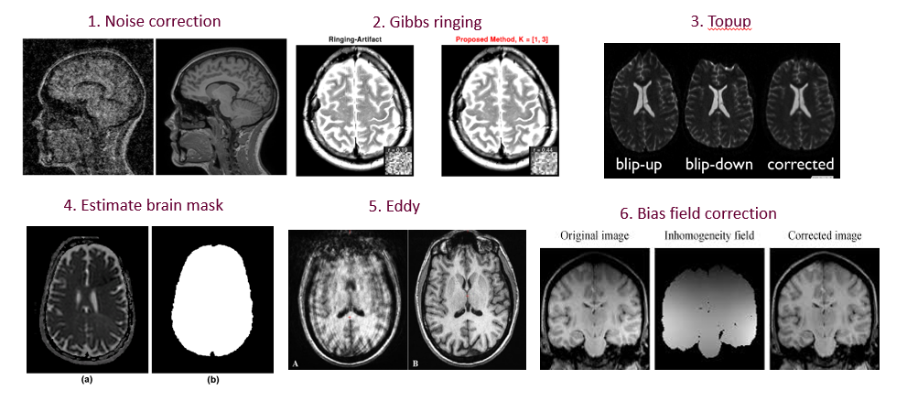

An overview of all of the MRtrix steps are here: <https://mrtrix.readthedocs.io/en/latest/>

*Tournier, J. D., Smith, R., Raffelt, D., Tabbara, R., Dhollander, T., Pietsch, M., … Connelly, A. (2019). MRtrix3: A fast, flexible and open software framework for medical image processing and visualisation.*

On the ***‘Nectar-Diff-GPU VM’*** (32 CPU cores with 96 GB RAM, 1 GPU (GeForce GTX 1080 card)), steps 1-6 take approximately 32 minutes per subject.

On the ***‘Dementia VM’*** (8 CPU cores with 8 GB RAM), steps 1-6 take approximately 1 hour and 35 minutes per subject. All timings are elapsed from 1 participant from the Dementia VM, unless otherwise stated. Once data is cleaned, then user may choose to run another pipeline to conduct further diffusion imaging analysis, such as for fitting diffusion tensors (e.g. VBA, TBSS) or fibre orientation models (e.g. BEDPOSTX, CSD).

Each completed preprocessed participant file is ~6.2 GB large, with 179 participants taking ~1110 GB or around 1 TB.

PREPROCESSING

1. **‘Pre-steps’:**

* First, create a derivatives folder for the output.
* Combine all diffusion data (the main dwi, the blip-up (BU), and the blip-down (BDs) – BU and BD are scans which are used for distortion correction)) to run steps 1 + 2 on them.
* Convert .nifti files to .mif files (mrtrix3 formatting) for processing.
* The input data for this step are the original source data files.

%Sample input: sub-ADPRC0012F0_acq_data_dwi.nii 🡪 ‘main dwi’ has 99 dwi + 5 non dwi, B0s/BUs (phase encoding anterior to posterior (a-p)) = 104 vol

sub-ADPRC0012F0_acq_BU_dwi.nii 🡪 1 non dwi , B0/BU (phase encoding

a-p)

sub-ADPRC0012F0_acq_BD1_dwi.nii

sub-ADPRC0012F0_acq_BD2_dwi.nii 🡪 3 BDs (phase encoding p-a)*

sub-ADPRC0012F0_acq_BD3_dwi.nii

*Typically, participants will have 3 BD files, but some earlier participant scans may have less.

Command: mrcat Combine all volumes (main dwi, BUs, and BDs) to run steps 1

+ 2 on them

mrconvert Convert .nii to .mif (mrtrix3 formatting) for processing

%Sample output: combined_sub-ADPRC001F0_acq_data_dwi.nii

combined_sub-ADPRC001F0_acq_data_dwi.mif

*fsleyes contrast setting for images below: min 100, max 3000*

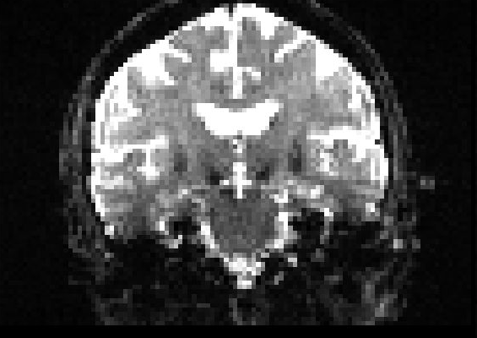 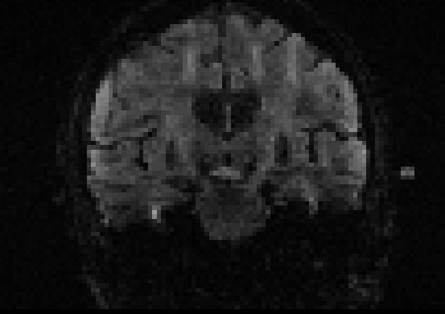

Non dwi - B0/BU (vol 0) dwi (vol 1)

1. **Denoising**

Noise correction is based upon principle component analysis of Marchenko-Pastur (MP-PCA) method. This thermal noise correction is the first step in data analysis due to an assumption about uncorrelated noise both spatially and across the diffusion space. The noise in the MR images can be described as a Rician distribution. MP-PCA estimates the standard deviation at each voxel for evaluation of the true signal.

*Veraart et al., (2016). Diffusion MRI noise mapping using random matrix theory.*

*Veraart et al., (2016). Denoising of diffusion MRI using random matric theory.*

%Sample input: combined_sub-ADPRC001F0_acq_data_dwi.mif

Command: dwidenoise Denoise the entire dataset (main dwi, B0/BUs and BDs).

%Sample output: dsub-ADPRC001F0_acq_data_dwi.mif 🡪 denoised data

noise_sub-ADPRC001F0_acq_data_dwi.mif 🡪 noise

res_sub-ADPRC001F0_acq_data_dwi.mif 🡪 residual data

The noise.mif file is the estimated spatially-varying noise level. Eyeball your residuals as part of quality control; compare raw data with the denoised data. If denoising did a good job, there should be little or no anatomy in the residual maps or the diffusion weighted images (this does not apply to the initial B0 – denoising should apply more to the higher shells). The lack of anatomy in the residual maps is a marker of accuracy and signal-preservation during denoising. Ideally, these residuals are Gaussian distributed with zero-mean and contain no anatomical structure.

Elapsed time: 2 min 20 sec

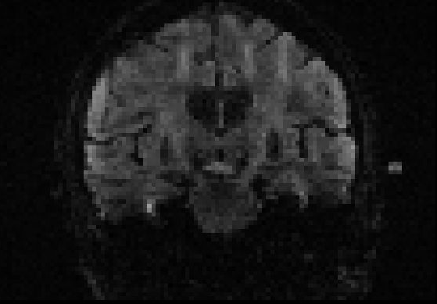 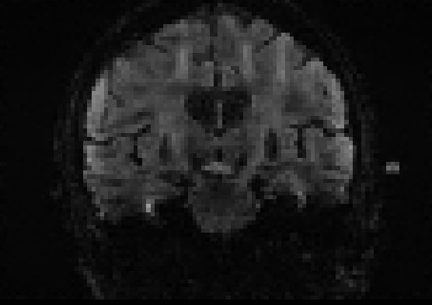

raw denoised

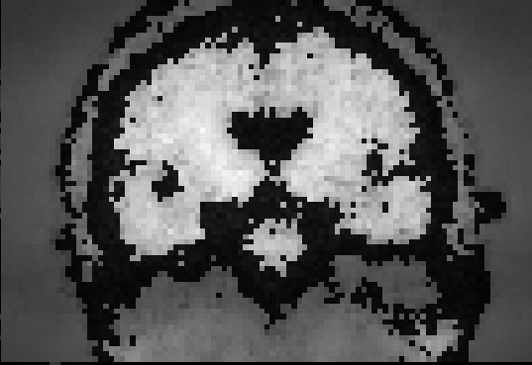 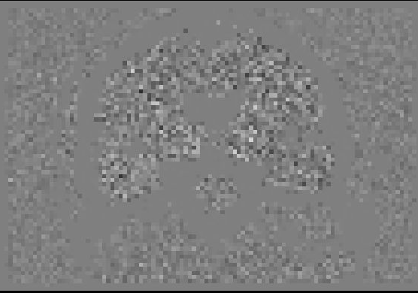 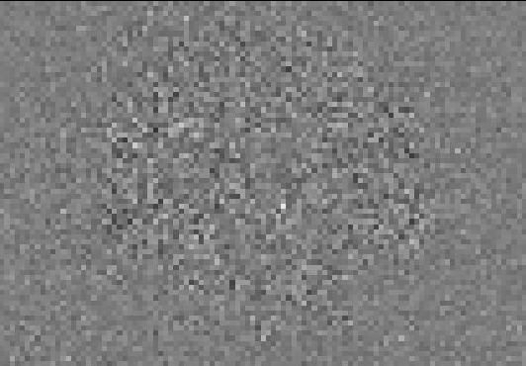

noise residual (b0) residual (b2000)

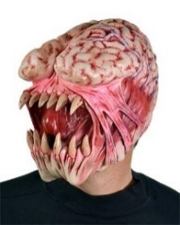

Checking your residuals is good for quality control!

<https://community.mrtrix.org/t/dwidenoise-residuals-map/1293/2>

1. **Gibb’s ringing**

Corrections for various artefacts, such as table vibration, radio-frequency-based distortions, and incorrect magnetic field gradient calibration, which can significantly degrade diffusion data. The Gibbs ringing artefact appears in k-space truncation along finite image sampling, and it can be suppressed by post hoc methods.

This method is based on local sub-voxel shifts. The strength of ringing (caused by truncation of Fourier transform space) is dependent on the location of the edge relative to the sampling grid. Method works by finding optimal sub-voxel shift in the neighborhood of shard edges.

*Kellner et al., (2016). Gibbs-ringing artefact removal based on local subvoxel shifts*

Both denoising and de-ringing should be applied to all volumes (including BUs and BDs):

<https://community.mrtrix.org/t/processing-of-volumes-prior-to-dwipreproc/2112>

Concatenating the data and applying these corrections, is suggested to be a better idea:

<https://community.mrtrix.org/t/preprocessing-questions/995>

%Sample input: dsub-ADPRC001F0_acq_data_dwi.mif

Command: mrdegibbs Like noise correction, perform Gibbs ringing correction on

the entire dataset (main dwi, BUs and BDs).

For DPRC dwi data, the x-y plane in which the slices were acquired where in the axial direction, and so you can add on the option of -axes 0,1.

%Sample output: gdsub-ADPRC001F0_acq_data_dwi.mif

Elapsed time: 20 sec

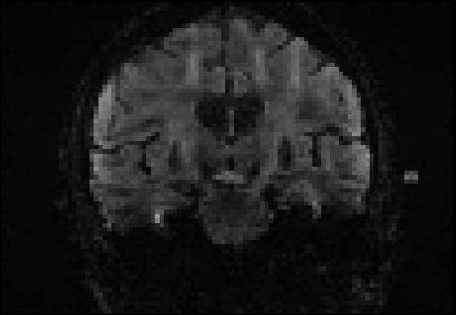 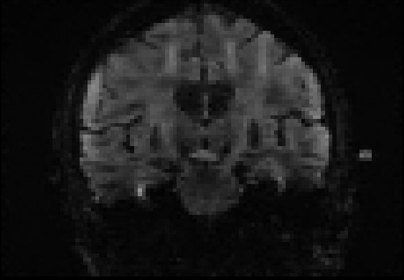

Denoised Gibbs corrected

**Edit gradient files:**

After the first 2 steps (denoising, gibbs) have been completed, we need to separate the data back out into the main dwi dataset and the p-a (BDs) to prepare for the next step, topup.

%Sample input: gdsub-ADPRC001F0_acq_data_dwi.mif

Command: mrconvert

%Sample output: cgdsub-ADPRC001F0_acq_data_dwi.mif 🡪 main dwi

PA_sub-ADPRC001F0_acq_data_dwi.mif 🡪 p-a (BDs); can be up to 3 vols

Then, for the dprc data specifically, we must edit the .bvec and .bval gradient files to add in the last B0 (BU) file (volume 106). The assumption is that the last BU will have the same parameters as the other BUs embedded in the main dwi dataset. These values (both in the .bval and .bvec files) should typically be around 0, and I have created a function for the last BU file to copy the first BU values as its own.

* Shell = firstB0, ~0 (.bval file)
* Vectors = ~0, ~0, ~0 (.bvec file)

Add the modified gradient files, now with the extra B0/BU with the main dwi data and to its header file.

%Sample input: PAR_NAME = participant ID, e.g. ‘sub-ADPRC001F0’

datafile = dwi datafile, e.g. ‘_acq_data_dwi’

Command: **LastB0AddOn.m** In-house function to edit gradient files

mrconvert with -fslgrad option Adds modified gradient value to the header

file of the data

%Sample output: bcgdsub-ADPRC001F0_acq_data_dwi.mif

1. **Topup**

Data acquisition is based on echo planar imaging (EPI), so must correct for distortions from magnetic field inhomogeneity. Reversed phase encoding method is used. Utilises TOPUP function from FSL, called through MRtrix. Opposite phase encoding directions for non dwi are posterior-anterior (PA).

We are preparing the appropriate B0s for topup/eddy. Note that MRtrix only accepts the number amount of a-p (BUs) and p-a (BDs) volumes (therefore, an even number in total) for this correction. However, again, note that not all participants have the same number of BD files – most have 3, but some have only 1 or 2, so the script accounts for this. There are also 6 BUs to choose from. My script implements the UKB ‘best B0’ (see below), with a function I created.

%Sample input: bcgdsub-ADPRC001F0_acq_data_dwi.mif

Command: dwiextract extract all B0s from the dataset

mrcat place a-p and p-a images into one file

%Sample output: AP_sub-ADPRC001F0_acq_data_dwi.mif 🡪 all a-p (BUs); 6 vols total

allB0s_ sub-ADPRC001F0_acq_data_dwi.mif 🡪 all a-p and p-a in one fie

1. **BestB0 pair selection:**

One best B0 pair (a-p, p-a) is selected and combined together for topup correction. First, all of the B0 images in both phase encoding directions (AP and PA) are aligned with one another with a rigid-body registration with 6 degrees of freedom (dof) (using fsl's FLIRT tool).

Next, the correlation is calculated between each of the b0 images to all of the others (fsl's FSLCC tool). Typically, the first BU and BD file are selected, and if their correlation is 0.98 or greater (Jesper's criteria), then we use that. The function checks that at least one of the B0 images has a cross-correlation greater than 0.95 - if not, then that participant is flagged, but will still use the highest (and earliest, if tied) cross-correlation B0 for it. If the first B0 has sufficient quality (a correlation of 0.98 or higher - Jesper's criterion), we would select this as the 'best B0 image' to use. If this is not the case, then the second B0 is checked, and so on, so forth. If none of the B0s have a higher correlation than 0.98, but there is at least one B0 greater than 0.95, then we would select for the highest correlation B0 (and earliest, if tied) for it.

A text file (BestB0.txt) is generated which will show the participant ID, the B0 status, and the BU and BD number used in the sequence.

In addition, the best BU volume, which is selected, will now be the first volume in the dwi sequence - the first volume and selected volume will switch places (if this is done). The gradient files (.bval and .bvec) should also be edited for this accordingly (in another function called **GradientEdit_forBestB0.m**). As suggested by Jesper, in a fsl community post: <https://www.jiscmail.ac.uk/cgi-bin/webadmin?A2=ind1703&L=FSL&P=R62904>

And confirmed from Jesper: <https://www.jiscmail.ac.uk/cgi-bin/wa-jisc.exe?A2=ind2007&L=FSL&O=D&X=65845096BD798100FD&Y=ltah262%40aucklanduni.ac.nz&P=94911>

*Note that any time you edit the gradient files (.bval and .bvec), you will need to re-import and provide the gradient files to the diffusion files by using the -fslgrad option. My script accounts for this. Only do this if the BU used is not the first one in the diffusion sequence.

%Sample input: PAR_NAME = participant ID, e.g. ‘sub-ADPRC0001F0’

datafile = dwi datafile, e.g. ‘_acq_data_dwi’

NumBDs = number of BD files participant has (typically 3)

startdir = start directory that you defined in the script - where the data will be stored.

Command: **BestB0.m** In-house function to carry select bestB0 pair

mrconvert Convert .mif files to .nii files for fsl processing

flirt Align all a-p and p-a images with rigid-body registration with 6 dof

fslcc Run cross-correlation with each volume and the registered image

%Sample output: bbcgdsub-ADPRC0001F0_acq_data_dwi.mif 🡪 dwi sequence w/ best a-p

as the first volume

TUB0s_sub-ADPRC0001F0_acq_data_dwi.mif 🡪 best B0 pair (1 a-p & 1 p-a) in one file

BestB0.txt 🡪 text file detailing the B0 status and B0s used

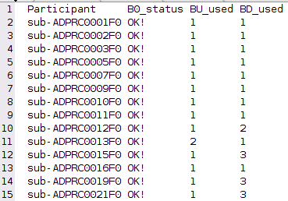

*Alfaro-Almagro, F., Jenkinson, M., Bangerter, N. K., Andersson, J. L. R., Griffanti, L., Douaud, G., … Smith, S. M. (2018). Image processing and Quality Control for the first 10,000 brain imaging datasets from UK Biobank.*

*Andersson, J.L.R., Skare, S., Ashburner, J. (2003). How to correct susceptibility distortions in spin-echo echo-planar images: application to diffusion tensor imaging..*

*Andersson & Sotiropoulos, (2016). An integrated approach to correction for off-resonance effects and subject movement in diffusion MR imaging*

*Smith, S.M., et al. (2014). Advances in functional and structural MR image analysis and implementation as FSL.*

*Skare, S. & Bammer, R. (2010). Jacobian weighting of distortion corrected EPI data. Proceedings of the International Society for Magnetic Resonance in Medicine, 5063.*

Elapsed time: 65 sec

*fsleyes contrast setting for images below: min 0, max 5000*

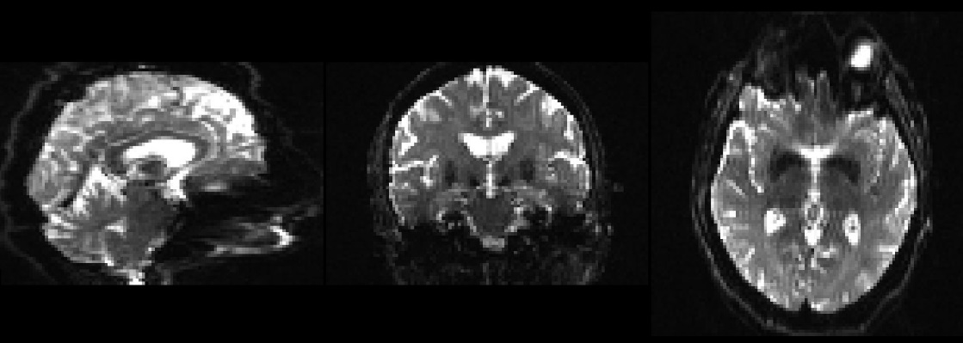

BU (blip-up)

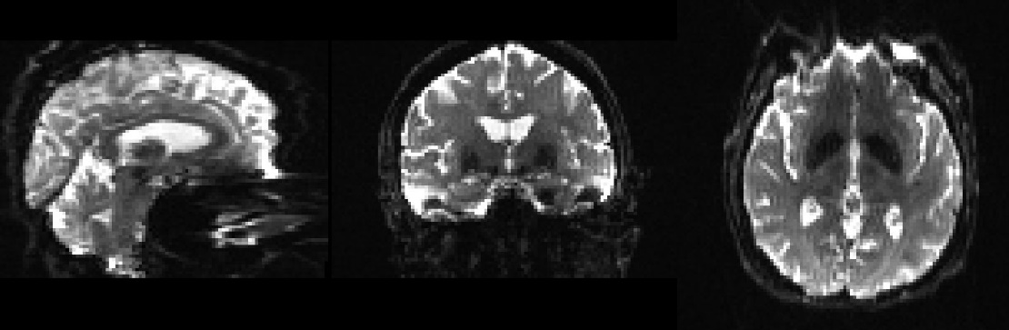

BD (blip-down)

<https://community.mrtrix.org/t/dwipreproc-register-fieldmap-to-dwi-other-questions/621>

reversed phase encoding input options:

<https://community.mrtrix.org/t/dwipreproc-option-2/1308>

dwifslpreproc only accepts and equal number of a-p and p-a volumes as inputs:

<https://community.mrtrix.org/t/dwipreproc-rpe-pair-why-equal-number-of-up-down-b0-encodings/957>

1. **Estimate brain mask**

Restricts analysis only to relevant voxels – i.e. keeps brain matter and removes non-brain matter (skull). A whole-brain mask is required for most analysis, and as an input to the subsequent steps. FSL’s BET was used for this because it was better than MRtrix’s dwi2mask; this may have been the case because of the current study’s cohort – see more info below. Comparison below:

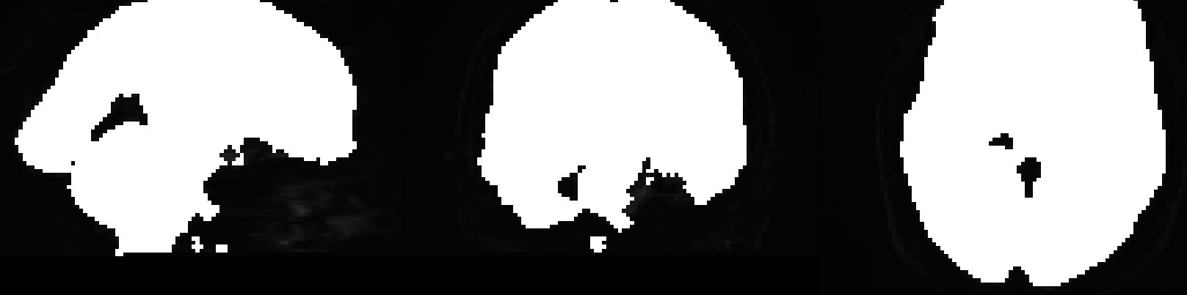

Dwi2mask with ants algorithm.

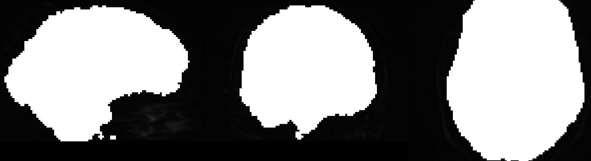

FSL’s BET algorithm.

%Sample input: TUB0s_sub-ADPRC001F0_acq_data_dwi.mif

combinedTUB0s_sub-ADPRC001F0_acq_data_dwi.nii

Command: fslmaths

bet threshold FA set at 0.2

%Sample output: combinedTUB0s_sub-ADPRC0001F0_acq_data_dwi.nii -> AP and PA

averaged across as one volume in one file

bet_sub-ADPRC0001F0_acq_data_dwi_mask.nii.gz -> the brain mask from

BET

This will be converted to brain_mask_sub-ADPRC0001F0_acq_data_dwi.mif

*Smith, S.M., (2002). Fast robust automated brain extraction*

Elapsed time: 2 sec

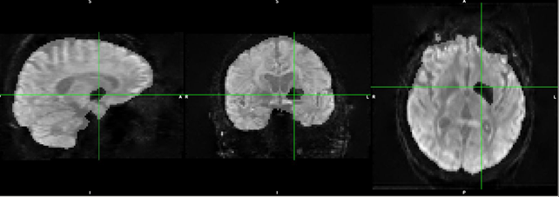

It is crucial to check that your brain masks for your participants are alright. Here, we can see that there is a ‘hole’ in this brain mask, where the pointer is. You may need to change the FA threshold if there are still holes in your brain mask.

Check your brain masks! Make sure it covers all ‘brain parts’.

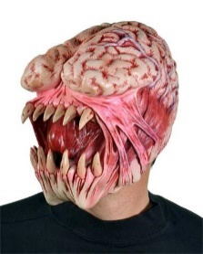

Note that BET (from fsl) and dwi2mask (from mrtrix) are different - you can read more about this hear from a community forum: <https://community.mrtrix.org/t/dwi2mask-holes-in-mask-images/484/13>. The gist is that they are both completely different algorithms, but are both suitable methods for brain extraction; however, dwi2mask is more suitable and made for diffusion data, while BET was more made for anatomical (T1) images. Also note that BET by default calls upon the BET2 program for simple brain extraction <https://fsl.fmrib.ox.ac.uk/fsl/fslwiki/BET/UserGuide>.

Note that it is okay if the brain mask is covering non-brain parts (e.g. eyeballs, sinus regions, etc). It is more problematic if there are holes in your brain mask, and you should go back and edit this in manually. Two posts from the MRtrix forum state this:

<https://community.mrtrix.org/t/problem-with-dwi2mask-result/3036>

<https://community.mrtrix.org/t/dwi2mask-creates-mask-with-insufficient-overage/3766/3>

*I have noted in a text file (manual_brain_masks.txt) which require manual input to fill in the ‘holes of the brain mask.’

1. **Eddy Currents**

Eddy and TOPUP work together to correct for distortions which appeared due to eddy currents, such as head motion and susceptibility originated artefacts. Also, for the rapid gradient field changes. This will make predictions about how the signal should look and uses ‘error signals’ to estimate and correct for the EC-induced field and subject movement.

Run FSL's eddy to correct for eddy currents and subject motion. Eddy will take the inputs from TOPUP and apply correction to all dwi images.

*Andersson & Sotiropoulos (2016) . An integrated approach to correction for off-resonance effects and subject movement in diffusion MR imaging*

All DWI volumes are acquired with precisely the same phase encoding direction and EPI readout time. In addition, one or more pairs of spin-echo b=0 EPI volumes are provided, where half of these volumes have the same phase encoding direction and readout time as the DWIs, and the other half have precisely the opposite phase encoding direction (but the same readout time). These additional images are therefore used to estimate the inhomogeneity field, but do not form part of the output DWI series.

*note that the whole process of topup + eddy current correction is also known as **geometric distortion correction (GDC)**.

%Sample input: bbcgdsub-ADPRC001F0_acq_data_dwi.mif 🡪 main dataset (dwi)

TUB0s_sub-ADPRC001F0_acq_data_dwi.mif 🡪 best B0 pair (1 a-p & 1 p-a) in one file (2 separate vol)

Command: RunEddy (in-house function)

dwifslpreproc run topup, eddy (w/ reversed phase encoding and -repol flag

option)

%Sample output: ebbcgdsub-ADPRC001F0_acq_data_dwi.mif

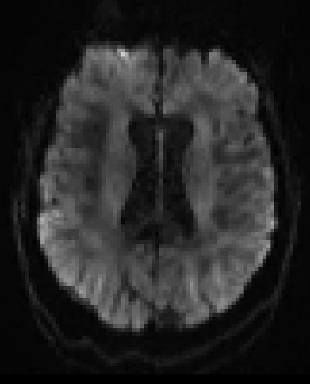 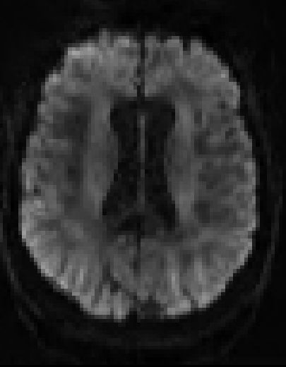

Gibbs ringing (pre-eddy) topup/eddy corrected

Fsl user guide wiki for using additional correction options in eddy: <https://fsl.fmrib.ox.ac.uk/fsl/fslwiki/eddy/UsersGuide#WARNING_this_page_is_being_edited_in_preparation_of_a_new_release_and_may_be_in_an_inconsistent_state>

<https://fsl.fmrib.ox.ac.uk/fsl/fslwiki/eddy#What_is_new_in_6.0.1.3F>

Specific correction options for eddy repol are: --repol --ol_nstd=3 --ol_type=both --mb=3

The --repol flag removes any slices deemed as outliers and replace them with predictions made by the Gaussian Process. While 4 standard deviations is a good compromise between type 1 and 2 errors for a "standard" data set of 50-100 directions, 3 SD has been suggested by Flavio Dell’ Acqua to be more stringent on the correction. Note that these corrections do not apply to removing any outlier slices in the b0s.

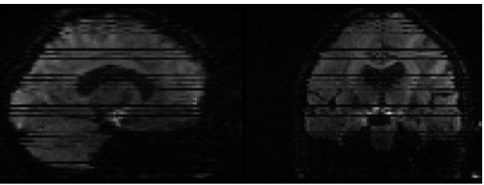

Raw data

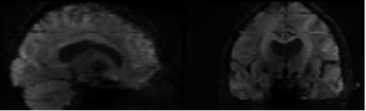

Post-eddy without repol

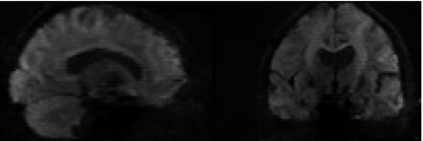

Post-eddy with repol

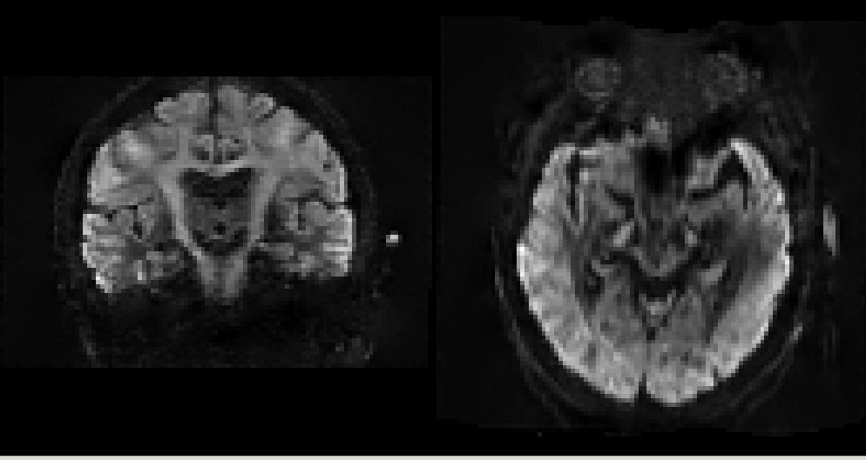 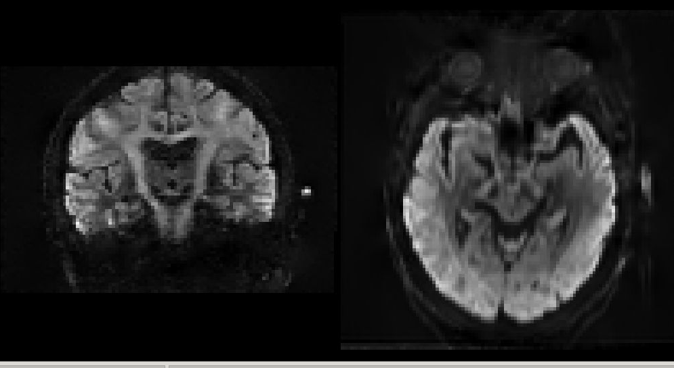

No repol option With repol option on

Repol is used for the slice dropout signals (i.e. stripes). Here, you can see the effects of eddy+repol from before, without repol and with repol correction.

*Andersson, J. L. R., Graham, M. S., Zsoldos, E. & Sotiropoulos, S. N. (2016). Incorporating outlier detection and replacement into a non-parametric framework for movement and distortion correction of diffusion MR images.*

Elapsed time: 1 hour 30 min*

*With eddy cuda implemented, this takes around 15-20 min long.

Large movement with dwi data: <https://www.jiscmail.ac.uk/cgi-bin/wa-jisc.exe?A2=ind2007&L=FSL&O=D&X=19672AE20F7AB86A04&Y=ltah262%40aucklanduni.ac.nz&P=214091>

If you will be performing the slice-to-volume motion correction (i.e. –mporder), you will need to have set up a GPU to use this. Slice-to-vol motion correction is computationally very expensive so it is only implemented for the CUDA version. My nectar vm is using cuda 9.1 with a GeForce GTX 1080 card. For the slice-to-vol motion correction, you can put these option flags, with the bolded ones required: **--mporder**, --s2v_niter, --s2v_lambda, --s2v_interp, and **--slspec**. You can read about this more on the fsl eddy user guide wiki page: <https://fsl.fmrib.ox.ac.uk/fsl/fslwiki/eddy/UsersGuide#A--mporder>

From fsl’s user guide wiki page, this is what the within-volume artefact looks like:

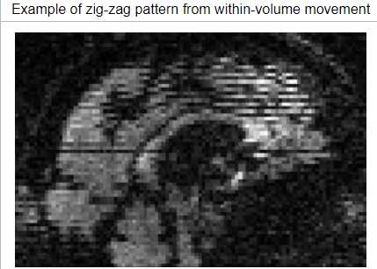

The slspec is a text file which specifies how the slices/multi-band (MB)-groups were acquired. DPRC mb factor = 3, and the number of slices is 72. And so, the number of rows = slices/MB, and columns = MB. Below is the slspec file from the DPRC data – you can obtain this data from the .json file, and by running the Matlab code as specified here: <https://fsl.fmrib.ox.ac.uk/fsl/fslwiki/eddy/Faq>. This file is stored in the ‘folders’ file in the main script file.

MB factor (M) = 3

# slices (N) = 72

Rows = N / MB = 24

Columns = M = 3

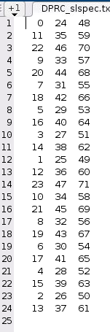

The first, 25th and 49th slices are acquired first and together, followed by the 12th, 36th, and 60th slice…etc.

Full command (FSL): eddy_cuda --imain=sub-ADPRC0012F0_acq_data_dwi --acqp=acqparams.txt --index=index.txt --mask=brain_mask_sub-ADPRC0012F0_acq_data_dwi --bvals=sub-ADPRC0012F0_acq_data_dwi.bval --bvecs=sub-ADPRC0012F0_acq_data_dwi.bvec --topup=topup_BU_BD --repol --ol_nstd=3 --ol_type=both --mporder=6 --s2v_niter=5 --slspec=DPRC_slspec.txt --out=eddy_corrected

Full command (MRtrix): dwifslpreproc bbcgd' PAR_NAME, datafile, '.mif ebbcgd' PAR_NAME, datafile, '.mif -rpe_pair -pe_dir AP -se_epi TUB0s_' PAR_NAME, datafile, '.mif -eddy_mask brain_mask_' PAR_NAME, datafile, '.mif -eddy_options " --repol --ol_nstd=3 --ol_type=both --mporder=6 --s2v_niter=5 --cnr_maps --residuals" -eddy_slspec=' ScriptDirectory '/files/DPRC_slspec.txt -eddyqc_all eddyqc -readout_time 0.07'

*Do note that if you will be using --mp_order, then you will need to omit the --mb option in the command.

sub-ADPRC_0036_F0 particularly had some bad movement, as shown in the bright zig-zag slices, thereby requiring the mp_order correction.

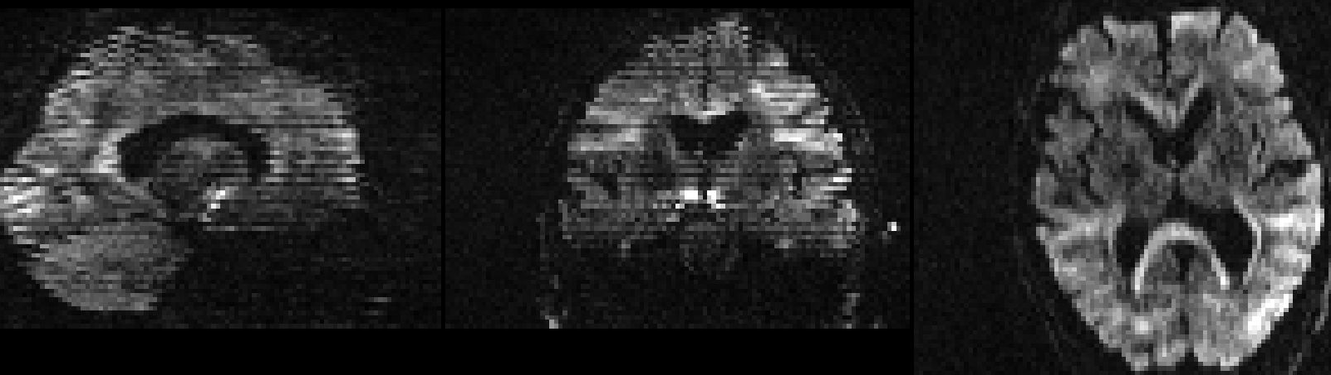

raw data

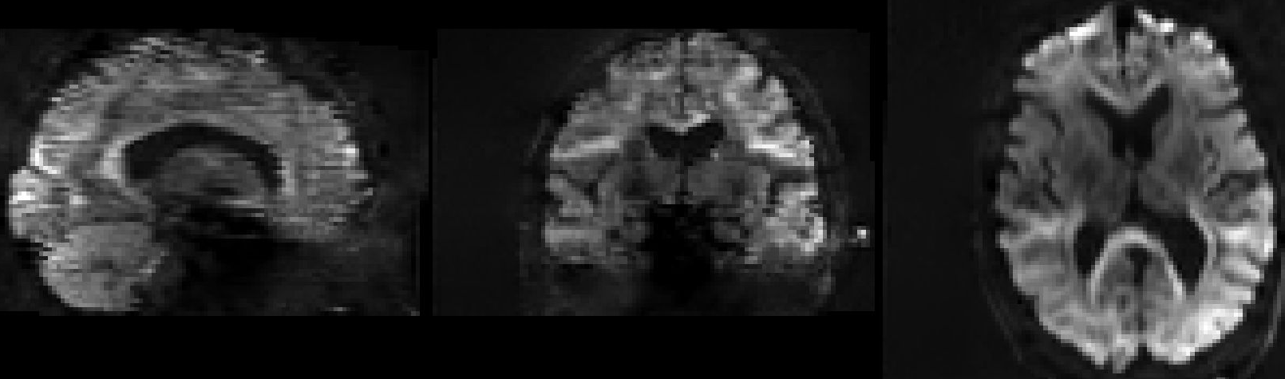

Post eddy with repol only

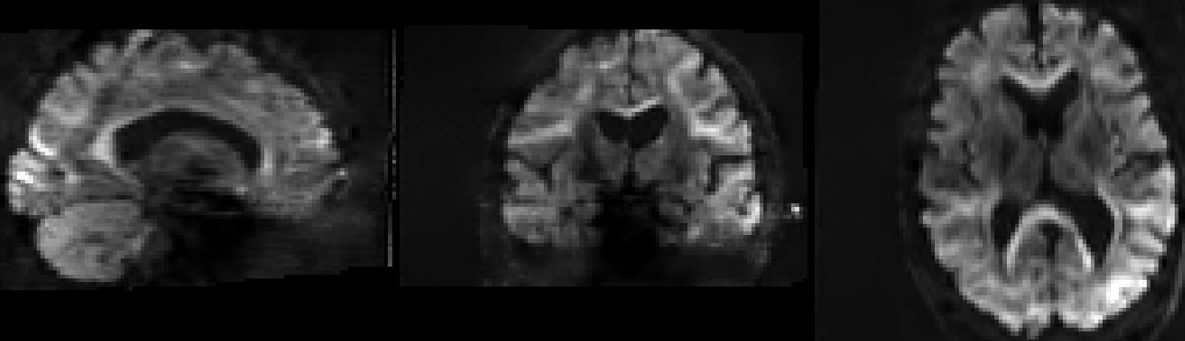

Post eddy with repol and --mp_order 6 option applied

*Andersson, J. L. R., Graham, M. S., Drobnjak, I., Zhang, H., Filippini, N., & Bastiani, M. (2017). Towards a comprehensive framework for movement and distortion correction of diffusion MR images: Within volume movement. NeuroImage, 152(November 2016), 450–466. https://doi.org/10.1016/j.neuroimage.2017.02.085*

1. **Perform eddy quality control (qc) per each participant**

We want to estimate the motion from each participant in order to later look at the overall motion of all of the participants in the dataset. The quality control of each participant (eddy_quad) will be used as input for the group quality control (eddy_squad), which comes at the very end of this script pipeline.

With eddy correction, I have added in a few options in order to generate the necessary text files to see the values of the motion from a variety of eddy qc measurements. In addition, we will run a quality control command (eddy_quad) with each participant.

Command: **eddyqc_ToText.m** In-house function to write eddy output text

files from each participant, together into one text file

This function will write values to text files for the movement over all volumes (**eddyqc_movement_all_vols.txt**), movement average (**eddyqc_movement_average.txt**), and the number and percent of outliers (**eddyqc_outliers.txt**). The user can then takes these values an put them into another programme (such as excel or R) to generate graphs and visualise any abnormalities/outliers among the participants. These files are all located in the *dwiqc* directory.

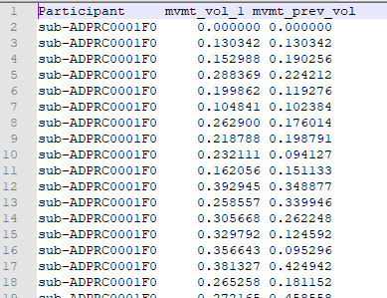 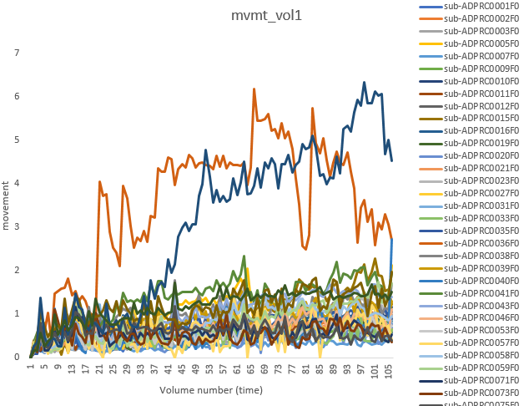

Example of looking at the absolute (movement from vol 1) and relative motion (movement from previous vol) across all volumes (**eddyqc_movement_all_vols.txt**) on the left, and plotting these values in a graph (such as in excel or R) on the right.

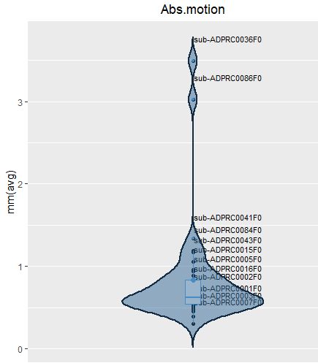

Example of the group absolute motion in a violin plot done with ggplot in R.

Elapsed time: < 1 sec

Command: **Run_EddyQuad.m**

eddy_quad (fsl command)

This function will generate a report of the quality control of eddy for each participant. It will create an *eddy_quad.qc* folder within each participant derivative/dwi/eddyqc folder, which will be used later to input into a group eddy qc analysis (via eddy_squad). This will ultimately help us to determine the outliers of the participants.

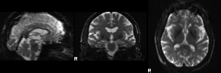 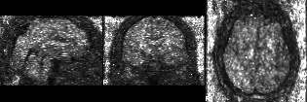avg_b0 cnr_b0

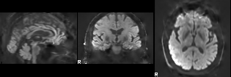 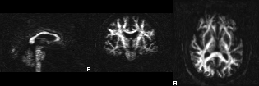

avg_b1000 cnr_b1000

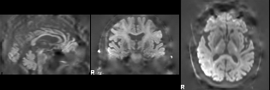 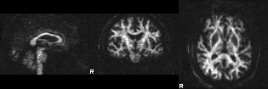

avg_b2000 cnr_b2000

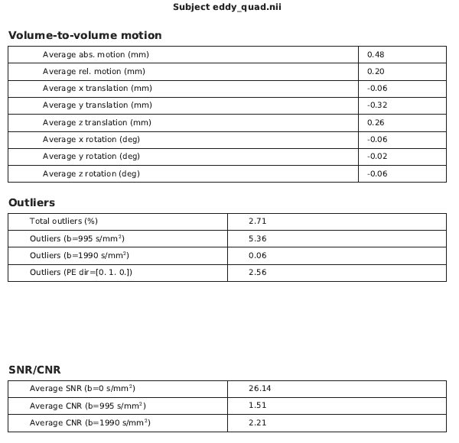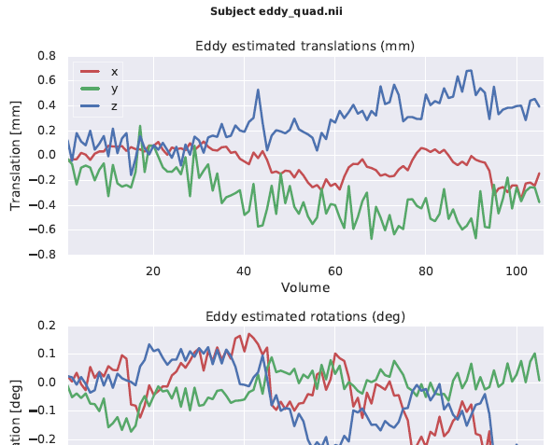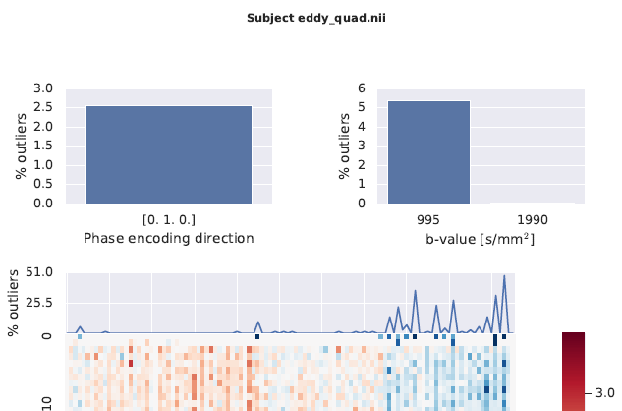

Some generated outputs from the qc.pdf file of a single participant.

Elapsed time: 39 sec

*Bastiani, M., Cottaar, M., Fitzgibbon, S. P., Suri, S., Alfaro-Almagro, F., Sotiropoulos, S. N., … Andersson, J. L. R. (2019). Automated quality control for within and between studies diffusion MRI data using a non-parametric framework for movement and distortion correction.*

Quality control over eddy data is a vital check to do!



1. **Bias Field correction**

To correct for field inhomogeneity caused by MR images possessing a low frequency intensity shift appearing as intensity inhomogeneity over the image. Utilises **ANTs** source code (N4BiasFieldCorrection), employed through MRtrix3. An initial (first-pass) brain mask is first generated, and then bias field correction (next step) is ran.

*Tustison, N. J., Avants, B. B., Cook, P. A., Zheng, Y., Egan, A., Yushkevich, P. A., & Gee, J. C. (2010). N4ITK: Improved N3 Bias Correction.*

%Sample input: ebbcgdsub-ADPRC001F0_acq_data_dwi.mif 🡪 main dataset (dwi)

initial_mask_sub-ADPRC001F0_acq_data_dwi.mif

Command: dwibiascorrect ants Correction is applied to the B0 images. Then the

corrected B0 images get applied to the rest of the dwi images

%Sample output: febbcgdsub-ADPRC001F0_acq_data_dwi.mif

Elapsed time: 17 sec

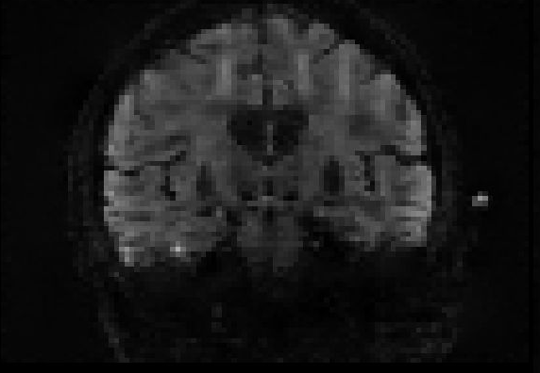 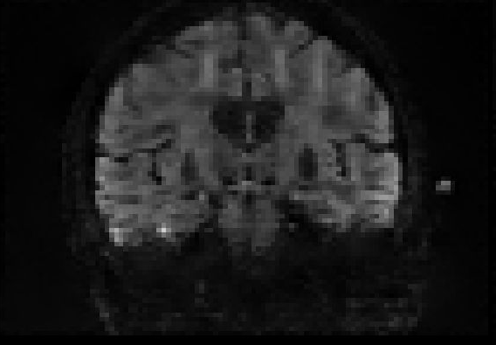 eddy corrected inhomogeneity field corrected

In some cases, the bias field correction might ‘black out’ the entire image, as shown below. In this case, what I have done is applied a more liberal dwi2mask with setting the clean_scale value=0 for this particular participant, and then re-ran the bias field correction. Generating a response function and applying joint bias field correction + intensity normalisation (later steps in the CSD pipeline) were okay with this. Maybe I am insane, but this method seems to not work on the nectar vm, but works on the dementia vm and my local computer…..

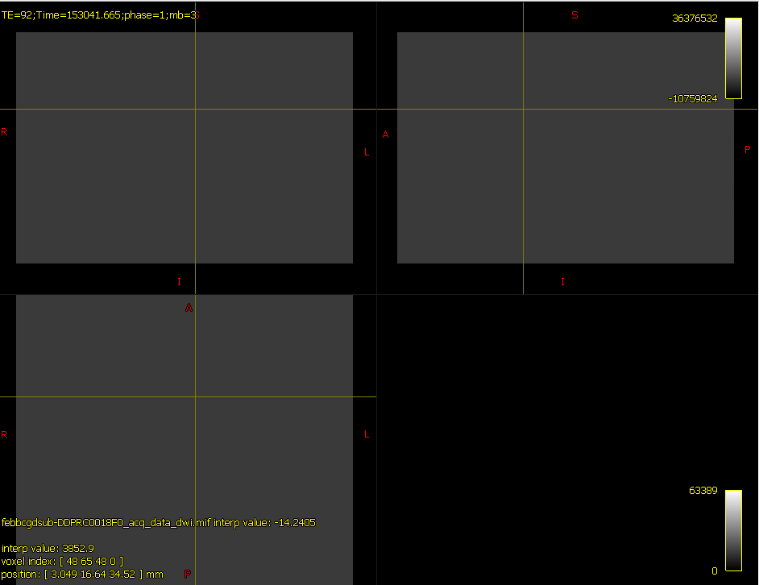

See reference here: <https://community.mrtrix.org/t/dwibiascorrect-after-dwipreproc/501>

**● Perform group motion (eddy) quality control**

This function will conduct 'eddy_squad', which will combine all participants' eddy qc data as a group study. Here, we will be able to view which participants seem like outliers. This will create a directory called 'squad' located in your ([startdir /derivatives/diff_data/dwiqc/squad]) folder. You can view the pdf file (group_qc.pdf) for the group summary report, and the JASON file (group_db.json) for specific values. My script already puts most of the values onto a text file (motion and outlier data), so if you want to extract more data from this file, go ahead. Remember to reference the original authors (e.g. Bastiani et al., 2019) who created this function!

Command: **Run_EddySquad.m**

eddy_squad (fsl command)

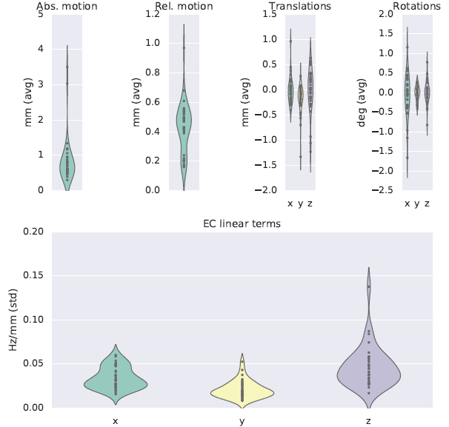

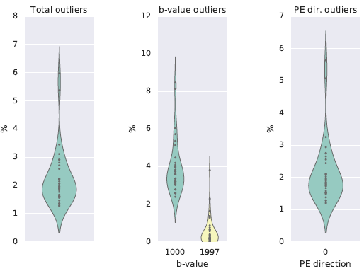 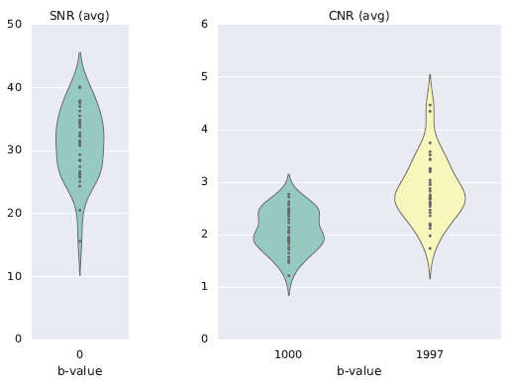

Output from group_qc.pdf (with 37 participants)

You can read more about eddy quality control and the outputs here: <https://fsl.fmrib.ox.ac.uk/fsl/fslwiki/eddyqc/UsersGuide>

<https://fsl.fmrib.ox.ac.uk/fsl/fslwiki/eddy/UsersGuide>

Elapsed time: 8 sec for 37 participants

*I have also created an R script (**qc_visualise.R**) in order to see the plots a bit better, and with all of the participants.

*Bastiani, M., Cottaar, M., Fitzgibbon, S. P., Suri, S., Alfaro-Almagro, F., Sotiropoulos, S. N., … Andersson, J. L. R. (2019). Automated quality control for within and between studies diffusion MRI data using a non-parametric framework for movement and distortion correction.*

**References**

Alfaro-Almagro, F., Jenkinson, M., Bangerter, N. K., Andersson, J. L. R., Griffanti, L., Douaud, G., … Smith, S. M. (2018). Image processing and Quality Control for the first 10,000 brain imaging datasets from UK Biobank. NeuroImage, 166(April 2017), 400–424. https://doi.org/10.1016/j.neuroimage.2017.10.034

Andersson, J. L. R., Graham, M. S., Drobnjak, I., Zhang, H., Filippini, N., & Bastiani, M. (2017). Towards a comprehensive framework for movement and distortion correction of diffusion MR images: Within volume movement. *NeuroImage*, *152*(November 2016), 450–466. https://doi.org/10.1016/j.neuroimage.2017.02.085

Andersson, J. L. R., Graham, M. S., Zsoldos, E. & Sotiropoulos, S. N. (2016). Incorporating outlier detection and replacement into a non-parametric framework for movement and distortion correction of diffusion MR images. *NeuroImage*, *141*, 556-572. https://doi.org/10.1016/j.neuroimage.2016.06.058

Andersson, J.L.R., Skare, S., Ashburner, J. (2003). How to correct susceptibility distortions in spin-echo echo-planar images: application to diffusion tensor imaging. NeuroImage, 20(2):870-888, 2003.

Andersson, J. L. R., & Sotiropoulos, S. N. (2016). An integrated approach to correction for off-resonance effects and subject movement in diffusion MR imaging. NeuroImage, 125, 1063–1078. https://doi.org/10.1016/j.neuroimage.2015.10.019

Bastiani, M., Cottaar, M., Fitzgibbon, S. P., Suri, S., Alfaro-Almagro, F., Sotiropoulos, S. N., … Andersson, J. L. R. (2019). Automated quality control for within and between studies diffusion MRI data using a non-parametric framework for movement and distortion correction. *NeuroImage*, *184*(September 2018), 801–812. https://doi.org/10.1016/j.neuroimage.2018.09.073

Kellner, E., Dhital, B., Kiselev, V. G., & Reisert, M. (2016). Gibbs-ringing artifact removal based on local subvoxel-shifts. Magnetic Resonance in Medicine, 76(5), 1574–1581. https://doi.org/10.1002/mrm.26054

Maximov, I. I., Alnæs, D., & Westlye, L. T. (2019). Towards an optimised processing pipeline for diffusion magnetic resonance imaging data: Effects of artefact corrections on diffusion metrics and their age associations in UK Biobank. Human Brain Mapping, 40(14), 4146–4162. https://doi.org/10.1002/hbm.24691

Perona, P., & Malik, J. (1990). Scale-Space and Edge Detection Using Anisotropic Diffusion. IEEE Transactions on Pattern Analysis and Machine Intelligence, 12(7), 629–639. https://doi.org/10.1109/34.56205

Skare, S. & Bammer, R. (2010). Jacobian weighting of distortion corrected EPI data. *Proceedings of the International Society for Magnetic Resonance in Medicine*, 5063.

Smith, S.M., (2002). Fast robust automated brain extraction. *Human Brain Mapping*, *17*(3), 143-155.

Smith, S.M., et al. (2014). Advances in functional and structural MR image analysis and implementation as FSL. NeuroImage, 23(S1), 208-219.

Tustison, N. J., Avants, B. B., Cook, P. A., Zheng, Y., Egan, A., Yushkevich, P. A., & Gee, J. C. (2010). N4ITK: Improved N3 Bias Correction. IEEE Transactions on Medical Imaging, 29(6), 1310–1320. https://doi.org/:10.1109/TMI.2010.2046908

Vellmer, S., Tonoyan, A. S., Suter, D., Pronin, I. N., & Maximov, I. I. (2018). Validation of DWI pre-processing procedures for reliable differentiation between human brain gliomas. Zeitschrift Fur Medizinische Physik, 28(1), 14–24. https://doi.org/10.1016/j.zemedi.2017.04.005

Veraart, J., Fieremans, E., & Novikov, D. S. (2016). Diffusion MRI noise mapping using random matrix theory. Magnetic Resonance in Medicine, 76(5), 1582–1593. https://doi.org/10.1002/mrm.26059.

Veraart, J., Novikov, D. S., Christiaens, D., Ades-Aron, B., Sijbers, J., & Fieremans, E. (2016). Denoising of diffusion MRI using random matrix theory. NeuroImage, 142, 394–406. https://doi.org/10.1016/j.neuroimage.2016.08.016

Veraart, J., Sijbers, J., Sunaert, S., Leemans, A., & Jeurissen, B. (2013). Weighted linear least squares estimation of diffusion MRI parameters: Strengths, limitations, and pitfalls. *NeuroImage*, *81*, 335–346. https://doi.org/10.1016/j.neuroimage.2013.05.028